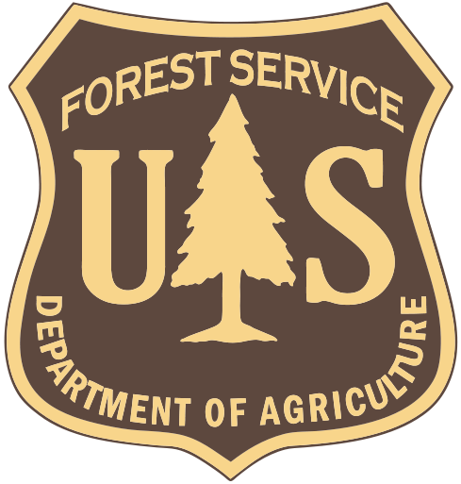
LAND USE DECISIONS BY THE GALLATIN NATIONAL FOREST FAIL TO PROVIDE HABITAT FOR VIABLE WILD BISON POPULATIONS

The U.S. Forest Service's "principal role" in the Interagency Bison Management Plan is to "provide habitat for bison" (Bison Management Plan for the State of Montana and Yellowstone National Park 2000). A goal of the Gallatin National Forest Plan is to "Provide habitat for viable populations of all indigenous wildlife species . . ." (United States Department of Agriculture, Forest Service, Gallatin National Forest Land and Resource Management Plan, PAGE II-1, 1987).

A "Clean-up Amendment" submitted for public scoping in September 2009 by the Gallatin National Forest proposes to remove its Forest Plan goal to "Provide habitat for viable populations of all indigenous wildlife species . . .” Online: http://www.fs.fed.us/r1/gallatin/?page=projects/forest_plan

The Gallatin does not provide any rationale specific to why it proposes elimination of this goal and states its 1987 Forest Plan will not be revised until "2014 or later". Proposing to remove managing habitat for viable wildlife populations is not an "outdated, ineffective or unnecessary direction" as the Forest claims. Additionally, because the Gallatin’s Forest Plan has not been updated every 15 years as required by the U.S. Congress, the Forest significantly delays a decision to permanently retire grazing allotments that have lingered in "vacancy" or “closed” status. While the agency may have administratively “closed” several grazing allotments, all too often the fencing, watering tanks, and other allotment infrastructure remain in place.

In response, Buffalo Field Campaign submitted a Clean-up Amendment recommending the Gallatin National Forest permanently retire vacant or closed grazing allotments on the Forest to help achieve the Forest's goal of providing habitat for viable populations of all indigenous wildlife species including wild bison.

On the Gallatin National Forest, the Hebgen Lake Ranger District and Gardiner Ranger District encompass the upper reaches of the Madison River, Gallatin River, and Yellowstone River valleys, the primary corridors for wild bison migrating from the Yellowstone plateau.

Over 105,000 acres of Gallatin National Forest lands are permitted for grazing private livestock on the Hebgen Lake and Gardiner Ranger Districts (Geist 2007).

Actual and potential bison habitat and migration corridors exist on Gallatin National Forest lands surrounding Yellowstone National Park (Jourdonnais 2006; Lemke 1997; Lemke 2006) but permitting private cattle grazing, particularly cow/calf pairs, and fencing off native wildlife habitat precludes wild bison from inhabiting Gallatin National Forest lands on a seasonal and year-round basis.
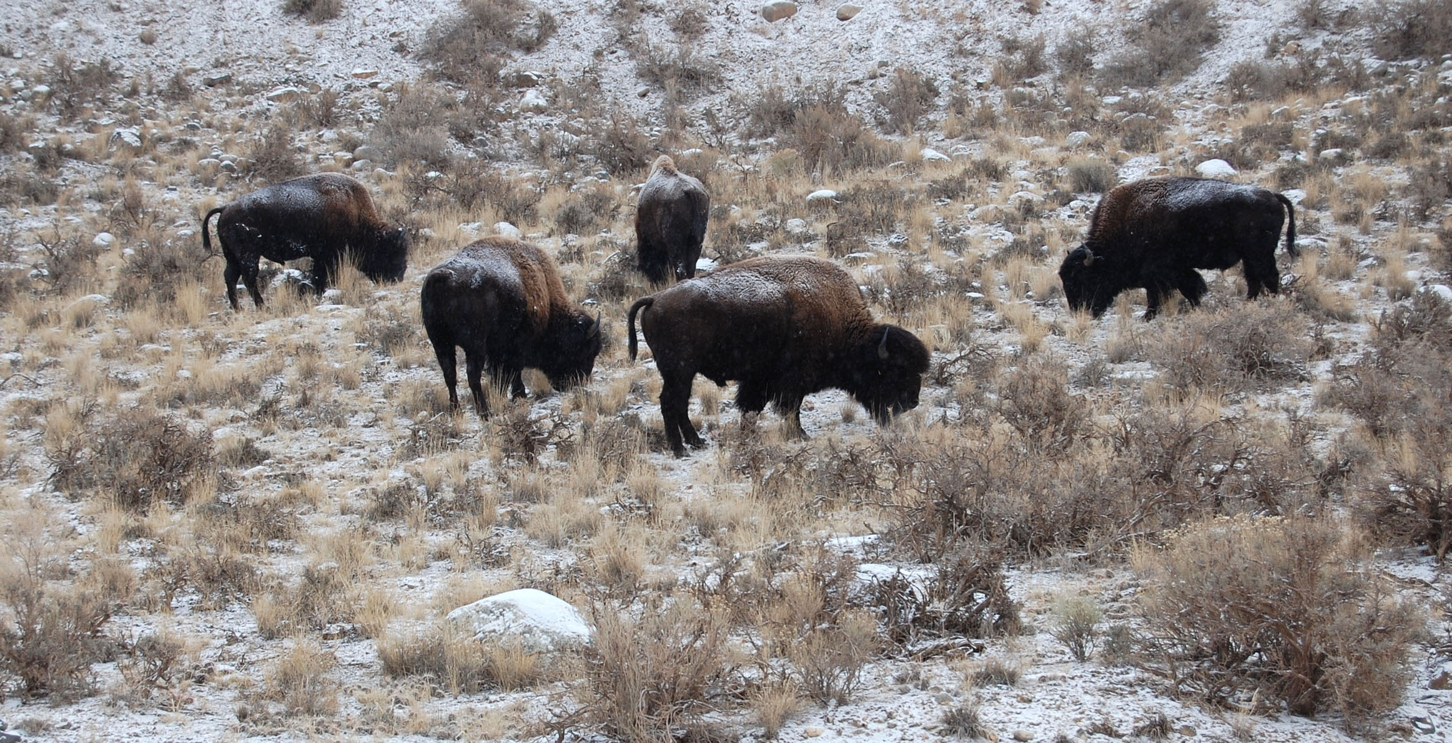
Bison grazing on winter range along Jardine Road near Eagle Creek, December 2007. Darrell Geist photo

In 2002, a US District Court ruling vacated the Horse Butte cattle grazing permit and enjoined the Gallatin National Forest from reissuing the allotment without proper National Environmental Policy Act review (Greater Yellowstone Coalition et al v. Dale Bosworth et al. 2002). No valid cattle grazing permit remains in use on the 9,600 acre Horse Butte peninsula. In 2007, the Galanis family who do not graze cattle and welcome wild bison on their land purchased the remaining cattle ranch on the peninsula. Recently, the Gallatin National Forest administratively closed the Horse Butte grazing permit but fencing still remains on the allotment.

In January 2009 the U.S. Forest Service renewed a 10-year special use permit (http://www.fs.fed.us/r1/gallatin/?page=projects/horse_butte) for the Montana Department of Livestock to continue operating its Horse Butte bison trap on the Gallatin National Forest. Since 1998 the Forest Service has authorized the livestock agency to capture bison migrating to this wildlife rich peninsula. Buffalo Field Campaign comments disputing the Forest’s decision is online: http://www.buffalofieldcampaign.org/legal/hbbisontrap.html

Renewing the Montana Department of Livestock's bison trap on Gallatin National Forest lands diminishes available bison habitat, disrupts bison's natural migration, and unnecessarily harms wild bison migrating to public lands on the Gallatin National Forest.
Bison hunting, proposed and existing bison traps and quarantine pens on federal, state, and private lands, and permitting the grazing and fencing of domestic livestock in bison’s native habitat on National Forest lands in the Gallatin National Forest is contributing to the loss of habitat for wild bison migrating from Yellowstone National Park along the Madison River, Gallatin River and Yellowstone River valleys.

Several land use decisions made by the U.S. Department of Agriculture and U.S. Forest Service illustrate the loss of available habitat for migrating bison on National Forest lands and adjacent private lands:

• Opening 23,000 acres in the Eagle Creek drainage to Montana’s bison hunt harmed wild bison wintering on Gallatin National Forest lands on the Gardiner Ranger District.
• Permitting the Montana Department of Livestock’s Horse Butte bison trap in 1998 and 2009 has displaced wild bison from habitat on Horse Butte peninsula – 9,600 acres of Gallatin National Forest lands that support an array of wildlife including grizzly bears, wolves, bald eagles, moose, and rare plant species like dwarf monkey flower.
• Completion of the 6,770 acre Royal Teton Ranch land conservation deal in the Gardiner basin in 1999 which the U.S. Forest Service was party to has failed to “provide a safe haven” for wild bison.
• The Gallatin National Forest's decision to renew for 10 years the Cache- Eldridge cattle grazing permit in the Taylor Fork Gallatin River drainage in potential bison winter range according to Montana Fish, Wildlife and Parks biologist Jourdannais (2006). The permit was recently waived back to the Forest however its availability to wild bison remains uncertain.
• The U.S. Forest Service acquisition of the 3,265 acre OTO Ranch in Cedar Creek bison winter range (Lemke 2006) east of the Yellowstone River in the Gardiner basin that bison are excluded from occupying in arbitrary "zone" management boundaries defined in the interagency plan.
• The U.S. Department of Agriculture's bison quarantine holding pens at Corwin Springs and Slip N Slide east of the Yellowstone River in the Gardiner basin have effectively displaced bison and harmed bison winter range as mapped by Montana Fish, Wildlife and Parks biologist Lemke (2006).

Without managing year round habitat in their native range, wild bison populations cannot be established on the Gallatin National Forest, a key habitat for this indigenous wildlife species. The cumulative effect of the U.S. Forest Service's grazing program and decisions on land use on National Forests is in direct conflict with the principal role prescribed for it, “to provide habitat for bison” and is biased against its own Forest Plan goal of managing habitat for this indigenous wildlife species.

