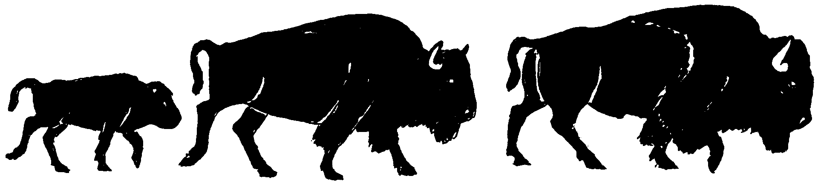

BUFFALO FIELD CAMPAIGN
P.O. BOX 957
WEST YELLOWSTONE, MONTANA 59758
406-646-0070
bfc-media@wildrockies.org * http://www.buffalofieldcampaign.org

May 28, 2011

Brian McCluskey
Western Regional Director
Veterinary Services, USDA-APHIS-VS
2150 Centre Avenue, Bldg B.
Fort Collins, CO 80526

Re: Freedom of Information Act Request, 5 U.S.C. § 552

Dear Director McCluskey,

On behalf of Buffalo Field Campaign, a Montana-based wild bison advocacy group representing tens of thousands of concerned citizens in Montana, throughout the United States and around the globe, working in defense of America’s last wild bison population, the Yellowstone herds, I file a Freedom of Information Act request.

This request pertains to the fifty-eight, and potentially up to 100, wild bison that were captured in the Stephens Creek bison trap and transferred to the Corwin Springs bison holding facility.

Yellowstone National Park stated numerous times that all buffalo captured during the 2011 season would be released. Yet, on Tuesday, May 24, 2011, when the buffalo at Corwin Springs were released, fifty-eight remained. When asked by Buffalo Field Campaign why these buffalo remained in captivity, Yellowstone public affairs personnel stated that they did not know, but that these buffalo were being turned over to the USDA-Animal & Plant Health Inspection Service, Veterinary Services (USDA-APHIS-VS).

On March 26, Yellowstone National Park issued a press release, which stated:

Fifty-three yearling through four-year-old bison remain in the Corwin Springs facility as a part of a USDA Animal and Plant Health Inspection Service initiated research project to determine whether brucellosis positive female bison can be prevented from shedding Brucella bacteria by treating them with a contraceptive vaccine.

The study requires a total of 80 to 100 bison, including some bison testing seronegative and some testing seropositive for brucellosis. At the end of the 7-year study, these bison will not be returned to the park. All bison that remain seronegative during the course of this study will be consigned to conservation programs or tribal restoration projects. Seropositive bison from this study may be consigned to slaughter at the conclusion of the research.

The Record of Decision, final Environmental Impact Statement of the Interagency Bison Management Plan states, “The final environmental impact statement (pp. 56-63) sets out several alternatives that the agencies rejected from in depth analysis. The [rejected] alternatives include … using birth control to control the size of the bison population, sterilizing bison to prevent the transmission of brucellosis, … We agree with the judgment of the EIS team to reject a full analysis of these alternatives. Most of them would not have met the goals of the planning process. Others would have had environmental impacts too significant to be within the reasonable range of alternatives."

Under the Freedom of Information Act Request, 5 U.S.C. § 552, Buffalo Field Campaign request that USDA-Animal & Plant Health Inspection Service Office of Veterinary Services expedites disclosure and provides public records, specifically:
- Please provide in electronic form on CD copies of documents outlining the authority under which USDA-APHIS-VS received 58 - and up to 100 - of America’s last wild buffalo from Yellowstone National Park for proposed immunocontraceptive vaccination.
- Please provide in electronic form on CD a copy of the permit that Yellowstone National Park issued to USDA-APHIS-VS to acquire these public bison immunocontraceptive vaccination, and all corresponding documentation.
- Please provide in electronic form on CD a complete copy of the complete USDA-APHIS-VS’s contraception vaccination project details, to include how and where the 58-100 bison will be taken for this project, how and when additional bison will be acquired, and reasons for the project.
- Please provide in electronic form on CD an age and sex breakdown of all bison being held in the Corwin Springs bison holding facility.
- Please provide in electronic form on CD all correspondence, documentation, emails, phone logs and any other information sharing between USDA-APHIS-VS and other agencies, groups or individuals in regards to USDA-APHIS-VS’s proposed immunocontraception vaccination.
- Please provide in electronic form, on CD, any and all notice USDA-APHIS-VS made available to the public, and any and all notice and opportunity for public comment regarding public bison from Yellowstone being consigned to USDA-APHIS-VS for said proposed immunocontraception vaccination.
- Please provide, in electronic CD format, documentation, communications, and other information that relieved Yellowstone and USDA-APHIS-VS from adhering to the Record of Decision, which rejected contraceptive vaccination as an alternative to consider due to significant environmental impacts to bison. Please explain why there was no notice given to the public regarding the intent of USDA-APHIS-VS to acquire these buffalo, and why there was no mention at the May 17-18 Interagency Bison Management Plan meetings that Yellowstone National Park would consign 58-100 public bison to USDA-APHIS-VS.
- Please provide, in electronic CD format, Yellowstone and USDA-APHIS-VS’s plans to acquire more buffalo (up to 42 additional) for USDA-APHIS-VS’s contraceptive vaccine project.
- Please provide, in electronic CD format, Yellowstone and USDA-APHIS-VS’s plans for sero-negative buffalo that may be transferred to conservation areas or tribal interests.
- Please provide, in electronic CD format, locations where APHIS will conduct immunocontraceptive vaccination.

As noted for each item, Buffalo Field Campaign requests that all records and documentation be provided in electronic form on a CD, so as to reduce cost and waste.

Buffalo Field Campaign requests an expedited response to our Freedom of Information Act Request.

Sincerely,

Stephany J. Seay
Buffalo Field Campaign
P.O. Box 957
West Yellowstone, MT 59758
406-646-0070
bfc-media@wildrockies.org
www.buffalofieldcampaign.org

