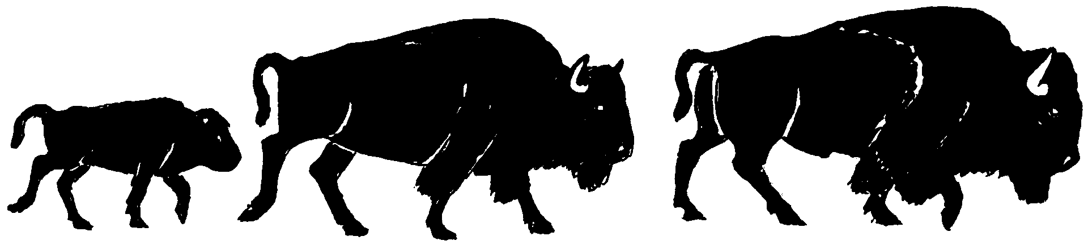

BUFFALO FIELD CAMPAIGN
P.O. BOX 957
WEST YELLOWSTONE, MONTANA 59758
406-646-0070
bfc-media@wildrockies.org * http://www.buffalofieldcampaign.org

May 28, 2011

Daniel Wenk
Superintendent
Yellowstone National Park
P.O. Box 168
Yellowstone National Park, WY 82190-0168

Re: Freedom of Information Act Request, 5 U.S.C. § 552

Dear Superintendent Wenk,

On behalf of Buffalo Field Campaign, a Montana-based wild bison advocacy group representing tens of thousands of concerned citizens in Montana, throughout the United States and around the globe, working in defense of America’s last wild bison population, the Yellowstone herds, I file a Freedom of Information Act request.

This request pertains to the fifty-eight, and potentially up to 100, wild bison that were captured in the Stephens Creek bison trap and transferred to the Corwin Springs bison holding facility.

Yellowstone National Park stated numerous times that all buffalo captured during the 2011 season would be released. Yet, on Tuesday, May 24, 2011, when the buffalo at Corwin Springs were released, fifty-eight remained. When asked by Buffalo Field Campaign why these buffalo remained in captivity, Yellowstone public affairs personnel stated that they did not know, but that these buffalo were being turned over to the USDA-Animal & Plant Health Inspection Service (USDA-APHIS-VS).

On March 26, Yellowstone National Park issued a press release, which stated:

Fifty-three yearling through four-year-old bison remain in the Corwin Springs facility as a part of a USDA Animal and Plant Health Inspection Service initiated research project to determine whether brucellosis positive female bison can be prevented from shedding Brucella bacteria by treating them with a contraceptive vaccine.

The study requires a total of 80 to 100 bison, including some bison testing seronegative and some testing seropositive for brucellosis. At the end of the 7-year study, these bison will not be returned to the park. All bison that remain seronegative during the course of this study will be consigned to conservation programs or tribal restoration projects. Seropositive bison from this study may be consigned to slaughter at the conclusion of the research.

The Record of Decision, final Environmental Impact Statement of the Interagency Bison Management Plan states, “The final environmental impact statement (pp. 56-63) sets out several alternatives that the agencies rejected from in depth analysis. The [rejected] alternatives include … using birth control to control the size of the bison population, sterilizing bison to prevent the transmission of brucellosis, … We agree with the judgment of the EIS team to reject a full analysis of these alternatives. Most of them would not have met the goals of the planning process. Others would have had environmental impacts too significant to be within the reasonable range of alternatives."

Under the Freedom of Information Act Request, 5 U.S.C. § 552, Buffalo Field Campaign request that Yellowstone National Park expedites disclosure and provides public records, specifically:
- Please provide in electronic form on CD copies of documents outlining the authority under which Yellowstone National Park consigned 58 - and up to 100 - of America’s last wild buffalo from Yellowstone National Park to USDA-APHIS-VS for proposed immunocontraceptive vaccination.
- Please provide in electronic form on CD a copy of the permit that Yellowstone National Park issued to USDA-APHIS-VS to acquire these public bison for immunocontraceptive vaccination, and all corresponding documentation.
- Please provide in electronic form on CD a complete copy of USDA-APHIS-VS’s contraception vaccination proposal details, to include where the 58-100 bison will be taken for this research project, and how and when additional bison will be acquired.
- Please provide in electronic form on CD an age and sex breakdown of all bison being held in the Corwin Springs bison holding facility.
- Please provide in electronic form on CD all correspondence, documentation, emails, phone logs and any other information sharing between Yellowstone National Park and USDA-APHIS-VS, and any other agencies, groups, or individuals in regards to USDA-APHIS-VS’s immunocontraceptive vaccination proposal.
- Please provide in electronic form, on CD, any and all notice made available to the public, and any and all notice and opportunity for public comment regarding public bison from Yellowstone being consigned to USDA-APHIS-VS for their immunocontraceptive vaccination proposal and other projects.
- Please provide, in electronic CD format, documentation, communications, and other information that relieved Yellowstone and USDA-APHIS-VS from adhering to the Record of Decision, which rejected contraceptive vaccination as an alternative to consider due to significant environmental impacts to bison. Please explain why there was no notice given to the public by Yellowstone National Park regarding the intent of Yellowstone to surrender these buffalo to USDA-APHIS-VS, and explain why there was no mention of this at the May 17-18, 2011 IBMP meetings.
- Please provide, in electronic CD format, Yellowstone and USDA-APHIS-VS’s plans to acquire more buffalo (up to 42 additional) for USDA-APHIS-VS’s immunocontraceptive vaccination proposal.
- Please provide, in electronic CD format, Yellowstone and USDA-APHIS-VS’s plans for sero-negative buffalo that may be transferred to conservation areas or tribal interests.
- Please provide, in electronic CD format, locations where APHIS will conduct immunocontraceptive vaccination of bison.

As noted for each item, Buffalo Field Campaign requests that all records and documentation be provided in electronic form on a CD, so as to reduce cost and waste.

The American public and the buffalo in your care have been betrayed by Yellowstone National Park’s actions. Buffalo Field Campaign requests an expedited response to our Freedom of Information Act Request.

Sincerely,

Stephany J. Seay
Buffalo Field Campaign
P.O. Box 957
West Yellowstone, MT 59758
406-646-0070
bfc-media@wildrockies.org
www.buffalofieldcampaign.org

